IBM MQ Managed File Transfer (MFT) Configuration

This setup demonstrates an MFT configuration between two servers for secure and reliable file transfer using IBM MQ. Below are the roles and responsibilities of each server:

|  |  |  |
| --- | --- | --- |
| **SERVER IP** | **HOSTNAME** | **ROLE** |
| 192.168.1.164 | MQFTESERVER | Coordination, Command QMGR, Agent (Receiver) |
| 192.168.1.181 | FTE SERVER | Agent (Sender) |

The **MQFTESERVER** (192.168.1.164) hosts the **Coordination Queue Manager, Command Queue Manager, and the Receiver MFT Agent**. It also has the full IBM MQ and MFT setup installed.

The **FTESERVER** (192.168.1.181) hosts only the **Sender MFT Agent** and has the minimal required FTE packages installed. There is no queue manager on this server.

**Required Packages (FTESERVER - Agent Only Node)**

|  |  |
| --- | --- |
| **Package Name** | **Purpose** |
| MQSeriesRuntime | Core runtime libraries needed for any IBM MQ-based component to function. |
| MQSeriesJava | Enables Java-based utilities (FTE Agents are Java apps). |
| MQSeriesJRE | Provides a dedicated Java Runtime Environment for MQ components. |
| MQSeriesFTBase | Base package for IBM MQ Managed File Transfer (MFT) – includes core MFT libraries. |
| MQSeriesFTAgent | Required to install and run the MFT Agent (this is the core agent package). |
| MQSeriesFTTools | Provides CLI tools like fteCreateAgent, fteCreateTransfer, etc. – required for operation. |
| MQSeriesGSKit | Global Security Kit – used for encryption, SSL/TLS support in secure MFT transfers. |

**MQFTESERVER Configuration Steps (192.168.1.164)**

**Step 1: Create the Queue Manager**

crtmqm FTEQM01; strmqm FTEQM01; runmqsc FTEQM01

**Step 2: Create MQ objects.**

1. Define a Local Queue (Optional) Used by agents for file messages or logs (can be customized as needed).

DEFINE QLOCAL(FTE.QL)

1. Create Listener

DEFINE LISTENER(L) TRPTYPE(TCP) PORT(1414) CONTROL(QMGR)

1. Create Server Connection Channel (for agent connections).

DEFINE CHANNEL(TO.FTEQM01) CHLTYPE(SVRCONN)

1. Temporarily Disable CHLAUTH (for testing only)

ALTER QMGR CHLAUTH(DISABLED)

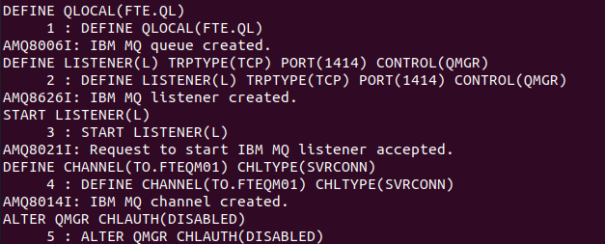

**Step 3: Setup the Coordination Queue Manager.**

This command sets up the coordination queue manager configuration files required by MFT.

./fteSetupCoordination -coordinationQMgr FTEQM01 -coordinationQMgrHost 192.168.1.164 -coordinationQMgrPort 1414 -coordinationQMgrChannel TO.FTEQM01 -f

The -f flag forces overwriting any existing configuration

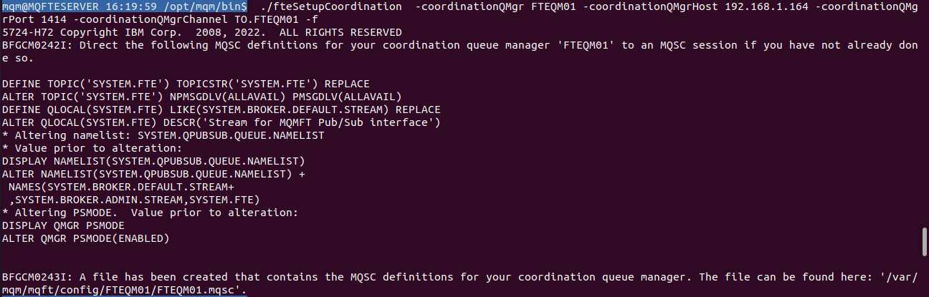

This will generate a .mqsc file at: /var/mqm/mqft/config/FTEQM01/FTEQM01.mqsc

**Step 4: Import MQSC Commands to Queue Manager**

Apply the MQ object definitions generated by the previous step into the queue manager:

runmqsc FTEQM01 < /var/mqm/mqft/config/FTEQM01/FTEQM01.mqsc

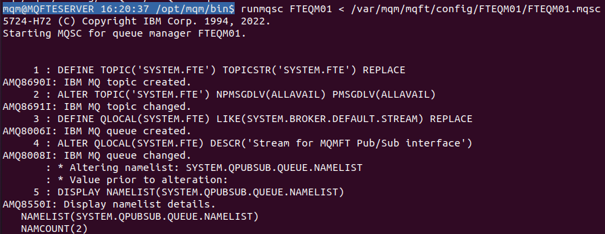

**Step 5: Create Command Queue Manager**

This configures the command queue manager properties that agents will use to communicate with the coordination queue manager.

./fteSetupCommands -connectionQMgr FTEQM01 -connectionQMgrHost 192.168.1.164 -connectionQMgrPort 1414 -connectionQMgrChannel TO.FTEQM01 -f



This creates the file: /var/mqm/mqft/config/FTEQM01/command.properties

**Step 6: Create MFT Agent (Receiver Agent on MQFTESERVER)**

./fteCreateAgent -agentname agent1 -agentQMgr FTEQM01 -agentQMgrHost 192.168.1.164 -agentQMgrPort 1414 -agentQMgrChannel TO.FTEQM01 -f

This creates the agent configuration directory: /var/mqm/mqft/config/FTEQM01/agents/AGENT1/

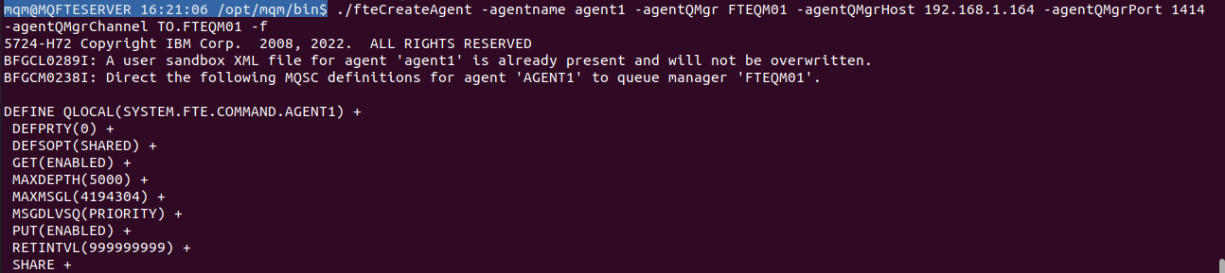

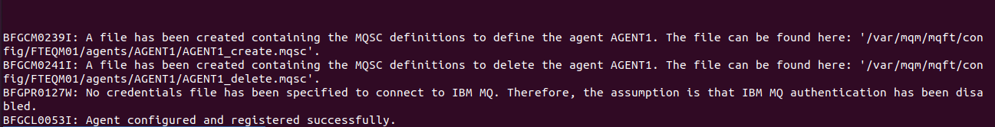

**Step 7: Import Agent MQSC File into Queue Manager.**

This step creates the necessary MQ queues for the agent within the queue manager.

runmqsc FTEQM01 < /var/mqm/mqft/config/FTEQM01/agents/AGENT1/AGENT1_create.mqsc

**Step 8: Start the Agent.**

./fteStartAgent agent1



If the agent starts successfully, it will begin listening for file transfer commands from the command queue manager.

**Step 9: To check the Agent status**

./fteListAgents

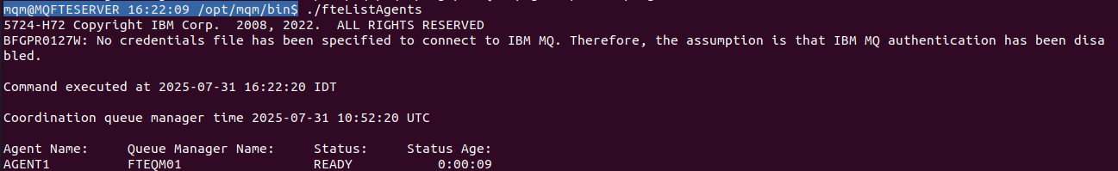

**FTESERVER (192.168.1.181) – Sender Agent Only Configuration:**

This server acts as the Sender Agent and does not have a local queue manager. It communicates with the Coordination QMGR hosted on MQFTESERVER.

**Step 1: Configure Remote Coordination Queue Manager**

./fteSetupCoordination -coordinationQMgr FTEQM01 -coordinationQMgrHost 192.168.1.164 -coordinationQMgrPort 1414 -coordinationQMgrChannel TO.FTEQM01

* This will generate a .mqsc file (which is already imported on the MQFTESERVER).
* This step helps establish the connection and configuration reference to the remote Coordination QMGR.

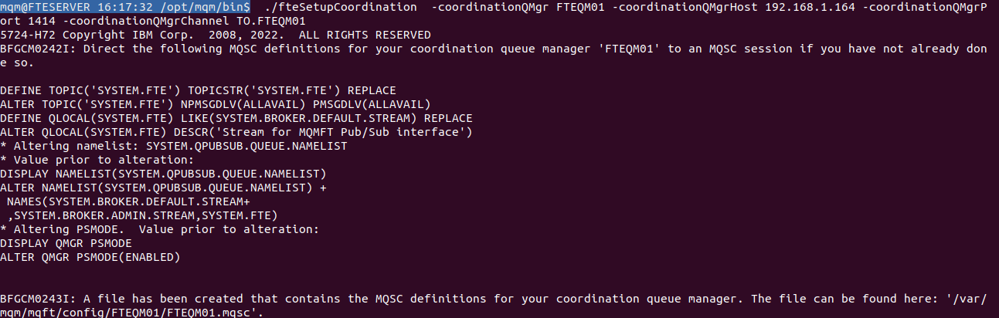

**Step 2: Configure the Remote Command Queue Manager.**

This creates the necessary configuration to allow file transfer commands to be sent to the agent using the remote command queue manager.

./fteSetupCommands -connectionQMgr FTEQM01 -connectionQMgrHost 192.168.1.164 -connectionQMgrPort 1414 -connectionQMgrChannel TO.FTEQM01

**Step 3: Create Sender Agent**

./fteCreateAgent -agentName AGENT2 -agentQMgr FTEQM01 -agentQMgrHost 192.168.1.164 -agentQMgrPort 1414 -agentQMgrChannel TO.FTEQM01

This will generate a .mqsc file.

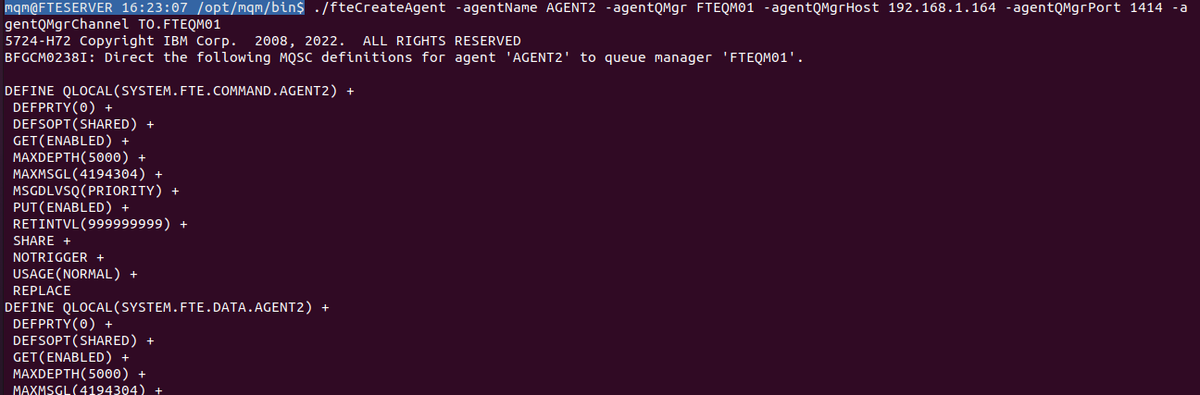

**Step 4: Transfer Generated MQSC Files to MQFTESERVER**

Copy both files to the MQFTESERVER (192.168.1.164), and import them into the coordination queue manager.

runmqsc FTEQM01 < AGENT2_create.mqsc

runmqsc FTEQM01 < FTEQM01.mqsc

**Step 5: Start the Agent in FTESERVER.**

./fteStartAgent AGENT2

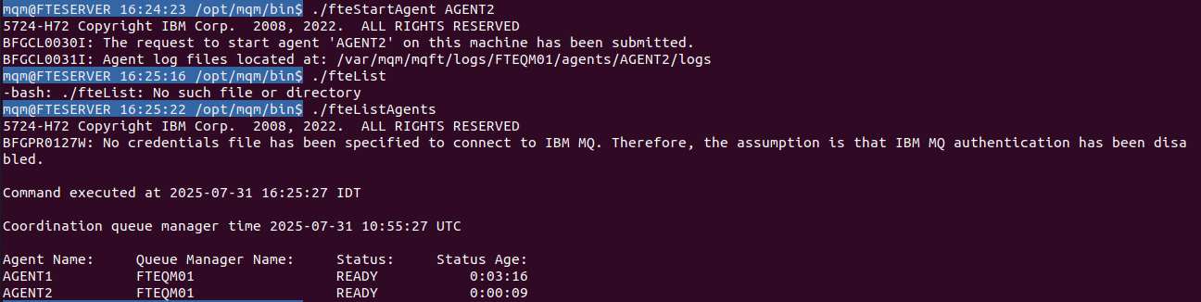

Both Agents are Now Ready.

You can now initiate file transfers from AGENT2 (sender on 192.168.1.181) to AGENT1 (receiver on 192.168.1.164), or vice versa using:

**TEST 1: MQFTESERVER → FTESERVER**

./fteCreateTransfer -sa AGENT1 -sm FTEQM01 -da AGENT2 -dm FTEQM01 -sf /tmp/mqft/sample.txt -df /tmp/mqft/sample.txt -overwrite always

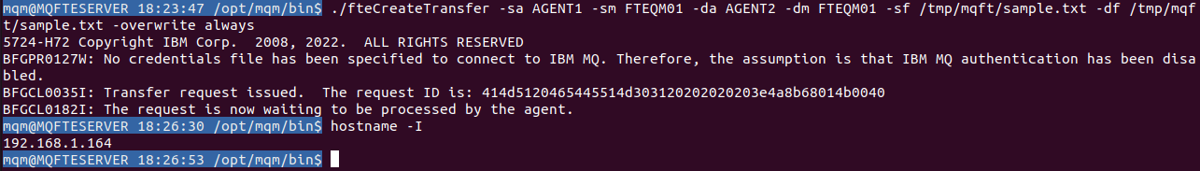

Check the folder and file is received at destination FTESERVER.

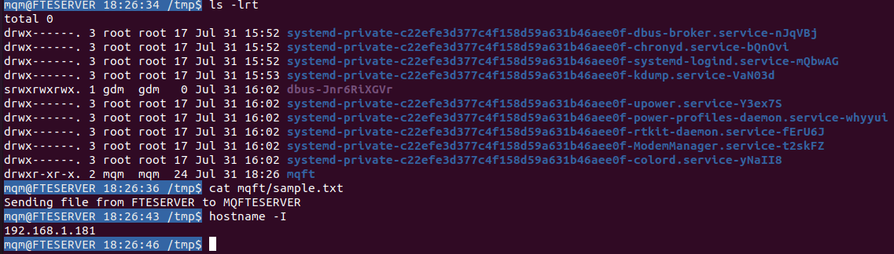

**TEST 2: FTESERVER → MQFTESERVER**

./fteCreateTransfer -sa AGENT2 -sm FTEQM01 -da AGENT1 -dm FTEQM01 -sf /tmp/mqft/fteserver.txt -df /tmp/mqft/fteserver.txt -overwrite always

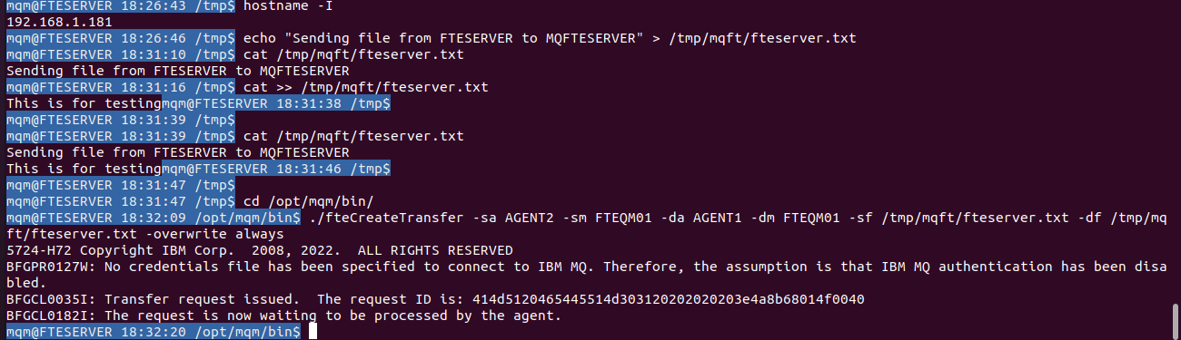

Check the file is received to MQFTESERVER.

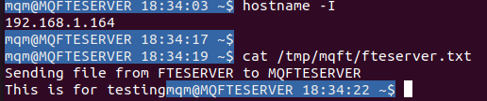

|  |  |
| --- | --- |
| **Parameter** | **Explanation** |
| ./fteCreateTransfer | This is the **IBM MQ MFT CLI command** to initiate a file transfer manually. |
| -sa AGENT2 | sa = source agent → the agent that **reads/sends** the file.AGENT2 is on **FTESERVER (192.168.1.181)**. |
| -sm FTEQM01 | sm = source agent's queue manager → the QM used by the sender. Both agents use the same QM (FTEQM01) in this setup. |
| -da AGENT1 | da = destination agent → the agent that **writes/receives** the file. AGENT1 is on **MQFTESERVER (192.168.1.164)**. |
| -dm FTEQM01 | dm = destination agent's queue manager → same QM is used here too. |
| -sf /tmp/mqft/fteserver.txt | sf = source file → path to the file on **FTESERVER** (sender). |
| -df /tmp/mqft/fteserver.txt | df = destination file → where to place the file on **MQFTESERVER** (receiver). |
| -overwrite always | If the file already exists at destination, **overwrite without asking**. |

./fteShowAgentDetails -p FTEQM01 AGENT1

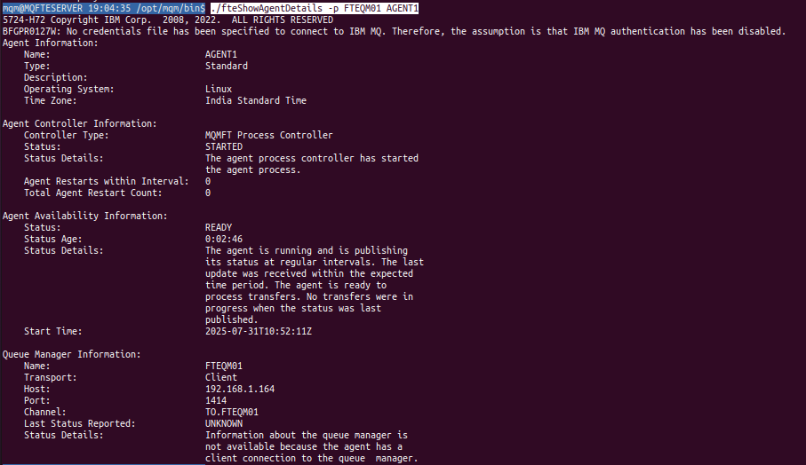

./fteShowAgentDetails -p FTEQM01 -v AGENT1

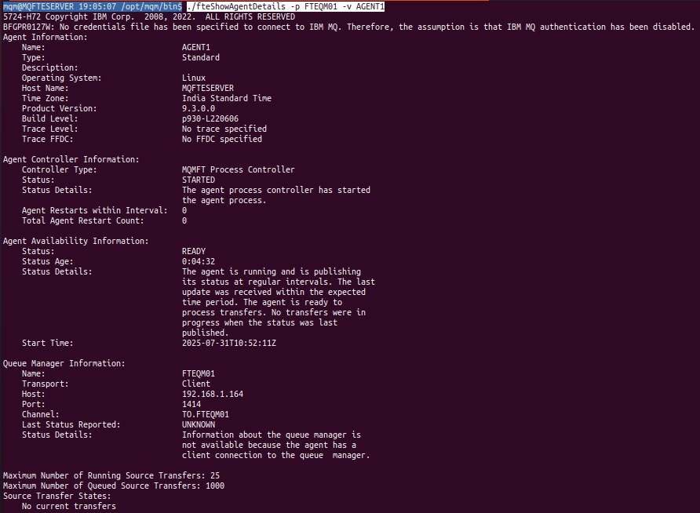

Transfer Capacity and Current Status:

Maximum Number of Running Source Transfers: 25

The agent (AGENT1) can handle up to 25 source transfers simultaneously — i.e., transfers originating from this agent.

Maximum Number of Queued Source Transfers: 1000

if more than 25 source transfers are requested at once, up to 1000 can be queued (waiting in line).

Source Transfer States: No current transfers

No active transfers are currently originating from this agent.

Maximum Number of Running Destination Transfers: 25

The agent can receive up to 25 transfers simultaneously.

Destination Transfer States: No current transfers

No active incoming transfers are happening at this moment.